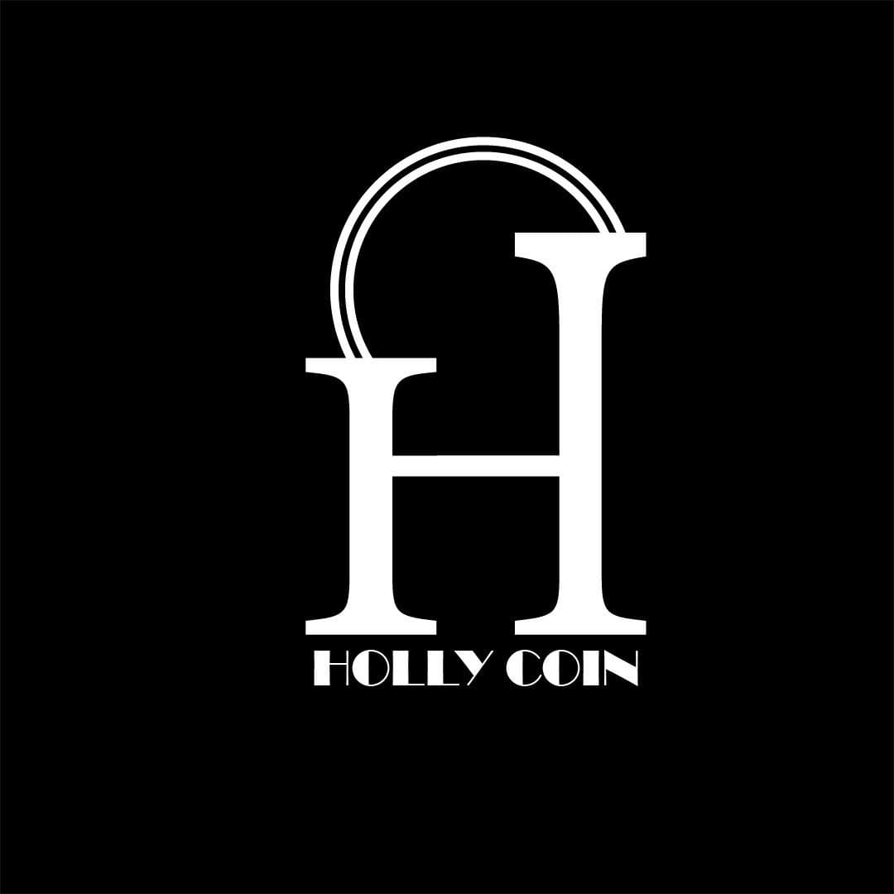

**HOLLYCOIN WHITEPAPER**

**TABLE OF CONTENTS**

1. **OVERVIEW**
2. **VISION**
3. **WHAT ARE NFT’S ?**
4. **REASON TO INTRODUCE HOLLYCOIN TO BLOCKCHAIN TECHNOLOGY**
5. **SCALABILITY**
6. **COMMUNITY DRIVEN**
7. **VALUE**
8. **FUTURE OF HOLLYCOIN**
9. **GREATEST MOVIES OF ALL TIMES & THEIR NFT’s**
10. **WHY BINANCE SMART CHAIN ?**
11. **ROADMAP**
12. **TOKENOMICS**
13. **WHY WE CHOOSE NFT’S ?**
14. **THE GROWING UTILITY OF NFT’S**
15. **USE OF PROCEEDS**

**1. OVERVIEW**

HOLLYCOIN is the NFT marketplace for Hollycoin assets. It is our vision to build a decentralised, community-owned marketplace where “HOLLY” holders will earn rewards from the NFTs sold on our marketplace. Hence, it serves as a platform for Hollywood enthusiasts to get into the NFT space.

**2. VISION**

Our vision for the ecosystem stretches far beyond its current use case.

The broader goal is to decentralise the entertainment industry. Through the Hollycoin token ecosystem, members can have a vote on NFTs and film production.

Films are currently funded by producers based on their discretion if the audience will like the film or not. In exchange, they reap the reward on investment in the form of profits. As opposed to a centralised film producer, directors could pitch movies directly to Hollywood enthusiasts. Imagine 3 trailers of potential movies shown to community members. The movie that raises the minimum funds needed in order to be produced first can win. Imagine 1000 community members buying the NFT for the movie. The director then uses the funds to produce the film.

The profits from the film are then distributed in accordance with token holding and community members earn discounts on future purchases of NFTs.

Users could also trade a fraction of the film or media produced*.

The logic is the audience should actively decide which films they want to produce, watch and even gain rewards from.

Another decentralised crypto platform where users pay to watch a movie in tokens would exist such that the owners of the NFT film can be paid in proportion to ownership.

**3. WHAT ARE NFT’S ?**

Towards the end of 2020 the crypto market began a new era with the explosion of the (non-fungible token) NFT market. Movie stars, famous artists, musicians, businessmen and investment funds have built a large portfolio of NFT tokens. Recently, Elon Musk’s recent partner, Grimes has created an NFT collection of her own work with a debut auction for a piece that sold for $5.8M in just 20 minutes.

NBA Top Shot is a blockchain-based platform that allows fans to buy, sell and trade limited versions of specific, officially-licensed clips. These highlights have sold for as much as $1M per version.

Beeple is one of the biggest NFT artists in the world having sold his artwork "Everydays: The First 5,000 Days", at Christie's - $69 million (March 11, 2021)

HOLLYCOIN aims to seamlessly act as the bridge between the Hollywood enthusiasts and this new emerging marketplace.

**4. REASON TO INTRODUCE HOLLYCOIN TO BLOCKCHAIN TECHNOLOGY**

The Hollywood industry has over 3 billion consumers who hold sentimental value in its content and for its creators.

Our platform HOLLYCOIN, where digital collectibles from the Hollywood industry will be auctioned on the Binance blockchain, provides an innovative way for Hollywood lovers from around the world to own NFTs of their favourite Hollywood films and celebrities of different eras.

We aim to be the world’s largest Hollywood NFT marketplace, partnering with the biggest producers and celebrities in the industry to create iconic and exclusive one of a kind NFTs.

**5. SCALABILITY**

The potential of combining Hollywood and decentralisation is enormous. Just imagine if the audience wasn’t passive anymore and played an active part in creating their own entertainment? What if this audience could choose what kind of content and films they want to be produced and even trade fractional ownership of pieces of this content?

Enabling the buying and selling of NFTs is just going to be the first step in a long evolution for our HOLLYCOIN marketplace.

**6. COMMUNITY DRIVEN**

Our marketplace enables the community to buy, trade and profit through the NFTs on our platform. Users can create their own cinematic universe and HOLLYCOIN rewards them for their participation & contribution to the community. We want the community to actively be a part in shaping what content we release next. Therefore, our community will be innovators, creators, collectors and consumers of Hollywood media. Beyond NFTs, HOLLYCOIN aims to create immersive, unique and irreplaceable experiences through the use of blockchain technology and its latest developments, shaped with the help of the community.

The value of a token largely depends on its community and the level of engagement. We at HOLLYCOIN understand the importance our community is going to play, and we believe that our ultimate success is going to be dependent on the community.

Every time a NFT is sold on our marketplace, “HOLLY” holders earn rewards in the form of Holly credits which can be used to purchase NFTs on our platform when it goes live.

Being the native digital utility token of the HOLLYCOIN ecosystem, each “HOLLY” issued would represent a voting right in matters relating to our community, such as which NFTs are to be created next.

**7. VALUE**

The value of HOLLYCOIN comes from its reward system and governance model. Since holding “HOLLY” has several benefits, its limited supply makes it a race between community members to get as many HOLLYCOINS as possible. Community members should work side by side on projects, on the same terms, towards the same goals.

What gives Hollycoin its value?

“HOLLY” holders will earn rewards in the form of Holly credits. These credits can only be used on the HOLLYCOIN platform for the purchase of NFTs and are not sellable in the open market.

The amount of Holly credits that gets credited are directly proportional to the amount of HOLLY” tokens held in the wallet and would depend on the value of NFTs sold for the month.

Holding “HOLLY” will hence earn rewards which can be converted into valuable Hollywood memorabilia.

**8. FUTURE OF HOLLYCOIN**

The future of HOLLYCOIN is limitless and the vision extends far beyond the NFT marketplace. During its evolution, we will endeavor to ensure that we create a governance model for the HOLLYCOIN community, wherein all decisions on non-corporate and non-regulatory matters pertaining to the NFTs for auction will be based on votes received from the HOLLYCOIN community members.

Such voting rights will be proportionate to the amount of tokens held in a member’s wallet. This will help the HOLLYCOIN team to ensure a decentralised and organic mechanism which will serve our community well in the long run.

**9. GREATEST MOVIES OF ALL TIMES**

HOLLYCOIN marketplace will showcase the NFT’s of Hollywood movies of different genre. Below is the list of shortlisted some of the greatest movies of all times for which NFT’s will be available at HOLLYCOIN.

1. **Old / Classical movies**

* The Circus
* Casablanca
* It’s a wonderful life
* All About eve
* 12 Angry Men
* The Apartment
* Psycho
* The Godfather series
* Chinatown
* Rocky

 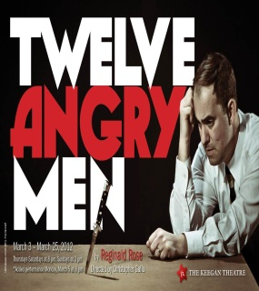 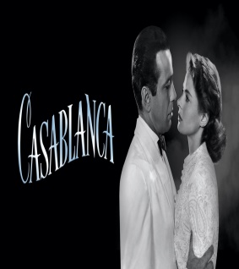 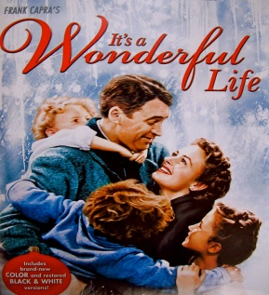 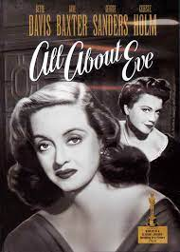

1. **Mid Era Movies**

* The Evil Dead
* Back to the future
* Schindler’s list
* Pulp fiction
* The Terminator
* Top Gun
* Pretty women
* Jurassic park
* Seven
* Mission Impossible
* Titanic
* The Matrix
* Fight Club

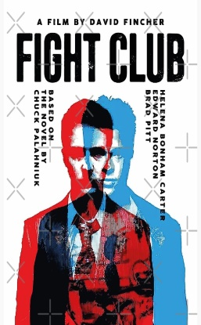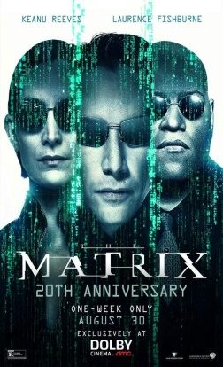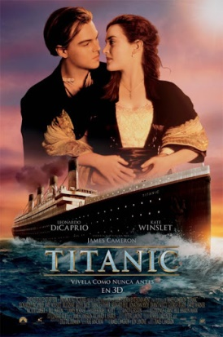 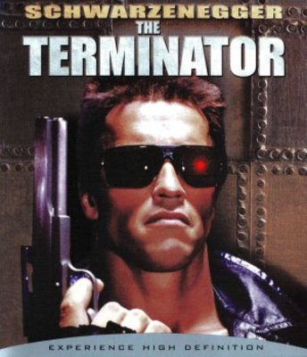

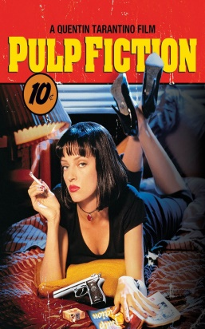 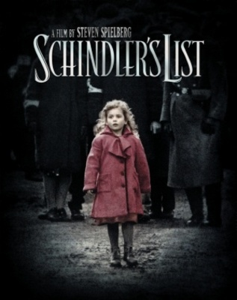 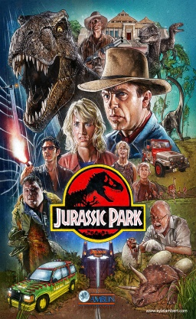 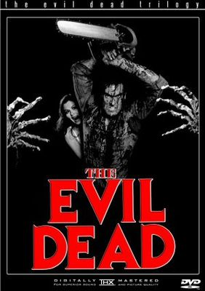 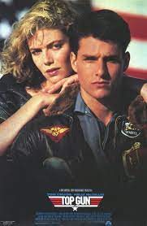

1. **21st Century Movies**

* American Psycho
* A Beautiful Mind
* Harry Porter
* Spider-man
* Batman series
* The Departed
* The Prestige
* Iron Man series
* Fast & Furious series
* The Hangover series
* Transformer series
* Twilight
* Life of PI
* Inception
* Intersteller
* The Martian
* Mission impossible series
* Avengers
* Captain America
* The Imitation game
* The Revenant

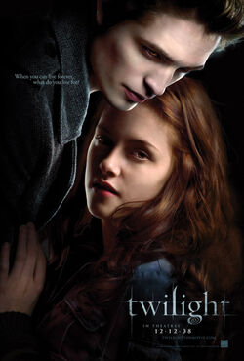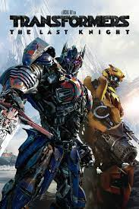 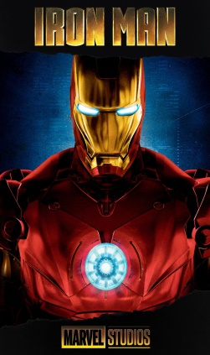

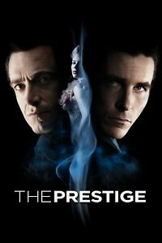  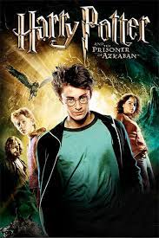 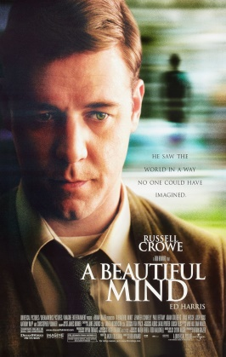 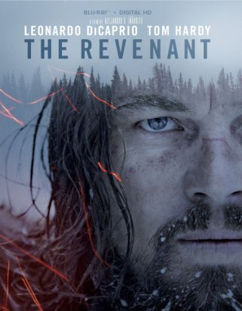

**10. WHY BINANCE SMART CHAIN ?**

Binance Smart Chain is a new platform that aims to lower transaction costs and provide a space to create DApps and other DeFi products.

It is focused on making DeFi affordable by offering a higher gas block limit and faster block times than Ethereum.

While it runs in parallel with BC, Binance Smart Chain is a standalone blockchain. This means that even if BC stops operating, BSC will continue to run its technical and business functions.

**11. ROADMAP**

**Dec 2021**

* Successfully verified the contract with 'HOLLY' ticker on BSC.
* Completed whitepaper with our aim and vision for HOLLY NFT marketplace and our community.

**Jan 2022**

* Website launch
* Creating a community which will gain rewards from the HOLLYCOIN and will govern its future operations.
* Launching on 1st centralised exchange as the first phase of token unlocking for the public sale

**Feb 2022**

* Launch of NFT marketplace with the NFTs of Hollywood movie actors, clips and characters for the Hollywood enthusiasts where they can buy, hold and resell NFTs and also can gain rewards.
* Listing on best crypto analysis websites like Coinmarketcap, Prices.org, CoinGecko etc.

**March 2022**

* Listing on Multiple Exchanges to grow our community
* Launching our own decentralised exchange for swapping HOLLY with other tokens and swapping NFTs with minimum fees.

**12. TOKENOMICS**

Name: HOLLYCOIN

SYMBOL: HOLLY

Contract: 0x9C4d272f05fFE2d51987A956069Bf7c8fe99FDc9

Blockchain: BSC Scan

Total Supply: 1,000,000,000 HOLLY

**TOKEN DISTRIBUTION**

* Public Sale 50%
* NFT marketplace 20%
* Community fund for rewards 10%
* Hollyswap 10%
* Seed Investors 4%
* Developers 3%
* Reserves 3%

**13. WHY WE CHOOSE NFTs?**

HOLLYCOIN chooses NFTs because these are one-of-a-kind and represent different movies. A non-fungible token is a one-of-a-kind asset that is controlled in a digital ledger and remains online. These digitally unique assets are associated with a distinct value and complemented by a certificate of authenticity, ensuring that the object cannot be readily and endlessly duplicated, even if it exists online.

**14. THE GROWING UTILITY OF NFTs**

When most people think of non-fungible tokens (NFTs), they think of their value as lying in their being unique – hence “non-fungible.” As one-off, digital representations of art, they are indivisible and non-replicable, to which people can attach value. But now there is a growing move to make NFTs usable in several different ways. This movement towards adding utility creates a different kind of value proposition for NFTs, on top of their scarcity and collectability.

Further novel concept is NFT staking or farming. This refers to staking NFTs to a protocol to earn a yield. It gives NFTs passive yield-generating utility, and can be thought of as decentralized finance.

Staking is unique as it allows holders to stake their NFTs to earn a yield and also continue to use them as in-game assets through its built-in lending system.

NFTs: Reshaping the gaming industry to favor play-to-earn models

More than half of the NFT market is attributable to in-game NFTs, with Axie Infinity alone enjoying over $2 billion worth of sales volume since its 2018 launch. NFTs are already demonstrating their significant disruptive potential in the gaming industry, with interest in play-to-earn gaming growing quickly.

**15. USE OF PROCEEDS / UTILITY**

HOLLY is a utility token aiming to sell all the art pieces in the form of NFTs where all NFTs will be digitally signed and true owner can be verified at any time.

* Firstly the rewards which the HOLLY holders will get to hold the tokens, buy the NFTs & participate in the voting process of next movie to be released.
* Secondly the funds will be allocated to produce more NFTs and launch them on the marketplace.
* Further funds will be used to introduce our own swap “Hollyswap” for the holding and swapping of tokens and NFTs.

1. **TEAM**
2. **Kaushiki Khanna**



1. **Neha Kathuria**



1. **Nitish Gupta**

